Test Case Examples for Building a Control

Requirement to test | Test Data Input | Expected Outcomes | Actual Outcomes
- Interface displayed correctly when the program runs | Run Program | 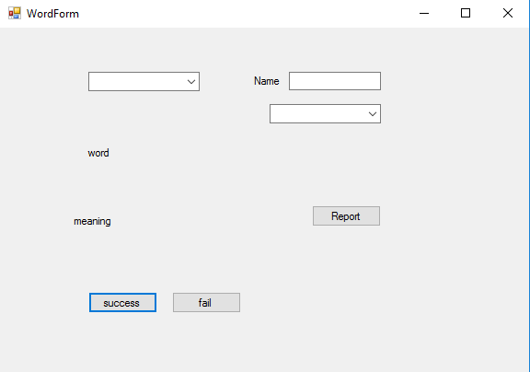 | Need to be modified
- User select role successfully | Select “teacher” | Screen shot | Need to be modified
- Add new words into words list. | Input each new word and its meaning, and then click “Add”, after entering all of the new words, click “save” | All the new words have been added to the words list successfully. | As expected
- Interface displayed correctly when the program runs | Run Program |  | Need to be modified
- User select role successfully | Select “student” | Screen shot | Need to be modified
- Study new words | Select “study” mode in the mode selector | Screen shot | As expected
 | Click “Show word” button | Screen shot | As expected
 | Click “Show word” button again and again till the list ends | Screen shot | As expected
- Enter non-valid operator test mode ......?????????????? | Enter your calculations here: %10+ | 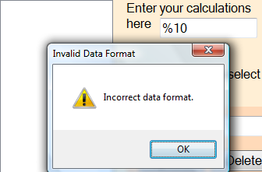 | As expected
 | Enter your calculations here: +10$%  Press Enter | Warning: Incorrect data format | As expected
- Enter alphabetic data | Enter your calculations here: asdf  Press Enter | 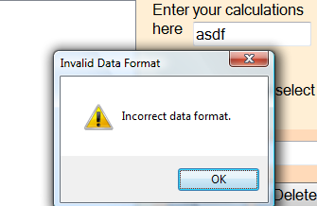 | As expected
- Enter alphabetic data and numeric data | Enter your calculations here: as25df  Press Enter | 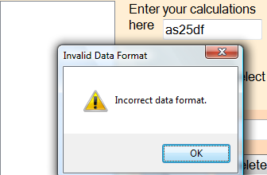 | As expected
- Enter operator and alphabetic data and numeric data | Enter your calculations here: +as25+ | 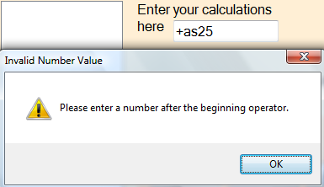 | ???????
- Enter non alphabetic and non numeric data | Enter your calculations here: %@!$  Press Enter | 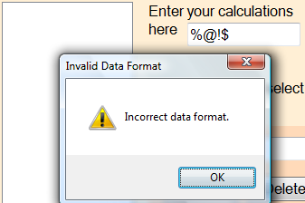 | As expected
 | Click on X to close the program | Program closes | As expected
- Interface displayed correctly when the program runs | Run Program | 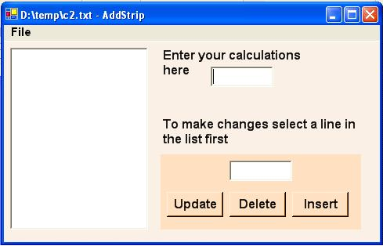 | As expected
- A simple single operator calculation that handles invalid characters and operations | Select menu:”File”---”Open...” | A openFileDialog displays | As expected
- A new calculation can be started | Enter your calculations here: +5+ | “+ 5” appears in the top of list box | As expected
 | Enter your calculations here: 7= | “+7” appears below “+5”;”= 12 << total” appears below “+7” | As expected
 | Select menu:”File”---”New” | Reminder the user to save the currrent work | As expected
 | Save the file | The file is successfully saved | As expected
 | Select menu:”File”---”New” | The list box and the textbox both display blank | As expected
- An existing file can be opened | Select menu:”File”---”Open...” | A openFileDialog displays | As expected
 | Select a existing cal file:”Calculation1.cal” | The listbox shows correctly the content in the opened file. | As expected
- A calculation can be saved | Enter your calculations here: +5+ | “+ 5” appears in the top of list box | As expected
 | Enter your calculations here: 7= | “+7” appears below “+5”;”= 12 << total” appears below “+7” | As expected
 | Select menu:”File”---”Save...” | A saveDialogBox displays to help to user to save the file | As expected
 | press “save” | The “Calculatio1.cal” is saved successfully. | As expected
 | Select menu:”File”---”Open” | A openFileDialog displays
 | Select a existing cal file:”Calculation1.cal” | The listbox shows correctly the content in the opened file. | As expected
 | Edit the calculation | The listbox displays the new calculation
 | Select menu:”File”---”Save...” | The calculation is saved automatically without displaying a saveDialogbox | As expected
- A calculation can be saved as another file | Enter your calculations here: +5+ | “+ 5” appears in the top of list box | As expected
 | Enter your calculations here: 7= | “+7” appears below “+5”;”= 12 << total” appears below “+7” | As expected
 | Select menu:”File”---”Save as...” | A saveDialogBox displays to help to user to save the file | As expected
 | press “save” | The “Calculatio1.cal” is saved successfully. | As expected
 | Select menu:”File”---”Open” | A openFileDialog displays
 | Select a existing cal file:”Calculation1.cal” | The listbox shows correctly the content in the opened file. | As expected
 | Select menu:”File”---”Save as...” | A saveDialogBox displays to help to user to save the file | As expected
 | Type the new file name “Calculation2.cal” | The “Calculatio2.cal” is saved successfully. | As expected
- A calculation can be printed | Enter your calculations here: +5+ | “+ 5” appears in the top of list box | As expected
 | Enter your calculations here: 7= | “+7” appears below “+5”;”= 12 << total” appears below “+7” | As expected
 | Select menu:”File”---”Print” | Print preview form displays, showing the lines of the calculation | As expected
 | User choose “Print” | The calculation would be printed | As expected
- The program can be exited | Select menu:”File”---”Exit” | The main form closes. | As expected
- A line can be deleted from a calculation | Enter your calculations here: +5+ | “+ 5” appears in the top of list box | As expected
 | Enter your calculations here: 7= | “+7” appears below “+5”;”= 12 << total” appears below “+7” | As expected
 | Select “+5” in the list box | “+ 5” appears in the edit text box | As expected
 | Press “delete” button | The line “+ 5” in the list box disappears and the new result ” =7<<total” display. | As expected
- A line can be updated in a calculation | Enter your calculations here: +5+ | “+ 5” appears in the top of list box | As expected
 | Enter your calculations here: 7= | “+7” appears below “+5”;”= 12 << total” appears below “+7” | As expected
 | Select “+5” in the list box | “+ 5” appears in the edit text box | As expected
 | change the “+5” in edit text box to “ +897” | It can be edited. | As expected
 | Press “update” button | The line “+ 5” in the list box change to “+897” and the new result ” =904<<total” display. | As expected
- A line can be inserted into a calculation | Enter your calculations here: +5+ | “+ 5” appears in the top of list box | As expected
 | Enter your calculations here: 7= | “+7” appears below “+5”;”= 12 << total” appears below “+7” | As expected
 | Select “+5” in the list box | “+ 5” appears in the edit text box | As expected
 | change the “+5” in edit text box to “ +101” | It can be edited. | As expected
 | Press “Insert” button | The line “+ 101” is added on the top of the line “+5” in the list box and the new result ” =113<<total” display. | As expected
- Check that Test files, extension .cal and C:\Temp\ is the default folder | Enter your calculations here: +5+ | “+ 5” appears in the top of list box | As expected
 | Enter your calculations here: 7= | “+7” appears below “+5”;”= 12 << total” appears below “+7” | As expected
 | Select menu:”File”---”Save as...” | A saveDialogBox displays to help to user to save the file, the defalt folder is C:\Temp\, and the extension of the file is .cal. | As expected
 | press “save” | The “Calculatio1.cal” is saved successfully. | As expected
 | Select menu:”File”---”Open” | A openFileDialog displays, the defalt folder is C:\Temp\, and only show the file with the extension of .cal. | As expected
- A calculation that includes an addition (+) only | Enter your calculations here: + | “+” appears in the textbox | As expected
 | Press Enter key | A warning dialog displays, showing “please enter a number after the beginning operator  ” | As expected
- A calculation that includes a Subtraction (-) only | Enter your calculations here: - | “-” appears in the textbox | As expected
 | Press Enter key | A warning dialog displays, showing “please enter a number after the beginning operator  ” | As expected
- A calculation that includes a Division (/) only | Enter your calculations here: / | “/” appears in the textbox ,A warning dialog displays, showing “the first character must be + or -” | As expected
- A calculation that includes a Multiplication (*) only | Enter your calculations here: * | “*” appears in the textbox ,A warning dialog displays, showing “the first character must be + or -” | As expected
- A calculation that includes an addition, a subtraction, a division, a multiplication and a total | Enter your calculations here: +1
 | Go on input: “-2” | One line appears in the listbox:  “+ 1” | As expected
 | Go on input: “*3” | Two lines appear in the listbox:  “+ 1”  “- 2”
 | Go on input: “/4” | Three lines appear in the listbox:  “+ 1”  “- 2”  “* 3”
 | Go on input: “=” | Five lines appear in the listbox:  “+ 1”  “- 2”  “* 3”  “/ 4”  “=-0.75<<total”
- A calculation that includes a Sub-total and a Total | Enter your calculations here: +1
 | Go on input: “-2#” | Three lines appear in the listbox:  “+ 1”  “- 2”  “#-1<subtotal” | As expected
 | Go on input: “*3”
 | Go on input: “/4=” | Six lines appear in the listbox:  “+ 1”  “- 2”  “#-1<subtotal”  “* 3”  “/ 4”  “=-0.75<<total” | As expected
- A calculation that includes a Total (reset to zero) | Enter your calculations here: +1
 | Go on input: “-2=” | Three lines appear in the listbox:  “+ 1”  “- 2”  “=-1<<total” | As expected
 | Go on input: “+3=” | Five lines appear in the listbox:  “+ 1”  “- 2”  “=-1<<total”  “+ 3”  “=3<<total” | As expected
- A calculation that includes 8 operators, 2 sub-totals and a total | Enter your calculations here: +1-2*3/4# | Five lines appear in the listbox:  “+ 1”  “- 2”  “* 3”  “/ 4 ”  “#-0.75<subtotal” | As expected
 | Go on input: +5-6# | Eight lines appear in the listbox:  “+ 1”  “- 2”  “* 3”  “/ 4 ”  “#-0.75<subtotal”  “+ 5”  “- 6 ”  “#-1.75<subtotal” | As expected
 | Go on input: *7/8= | Eleven lines appear in the listbox:  “+ 1”  “- 2”  “* 3”  “/ 4 ”  “#-0.75<subtotal”  “+ 5”  “- 6 ”  “#-1.75<subtotal”  “* 7”  “/ 8 ”  “=-1.53125<<total” | As expected
- The user is warned about unsaved data when closing the form. | Enter your calculations here: +5+ | “+ 5” appears in the top of list box | As expected
 | Enter your calculations here: 7= | “+7” appears below “+5”;”= 12 << total” appears below “+7” | As expected
 | Select menu:”File”---”Exit” | A MessageBox displays ”  Are you sure you want to exit without saving the current calculation? ” to remind the user to save before exit | As expected
 | Select ”Cancel” | A saveDialogBox displays to help to user to save the file, the defalt folder is C:\Temp\, and the extension of the file is .cal. | As expected

